**Defect Report**

|  |  |
| --- | --- |
| **Defect 01** | Get Savings now does not redirect user to offers. |
| **Expected result** | User must be redirected to the clearance products. |
| **Actual result** | When user clicks on it, only refreshes the URL. |

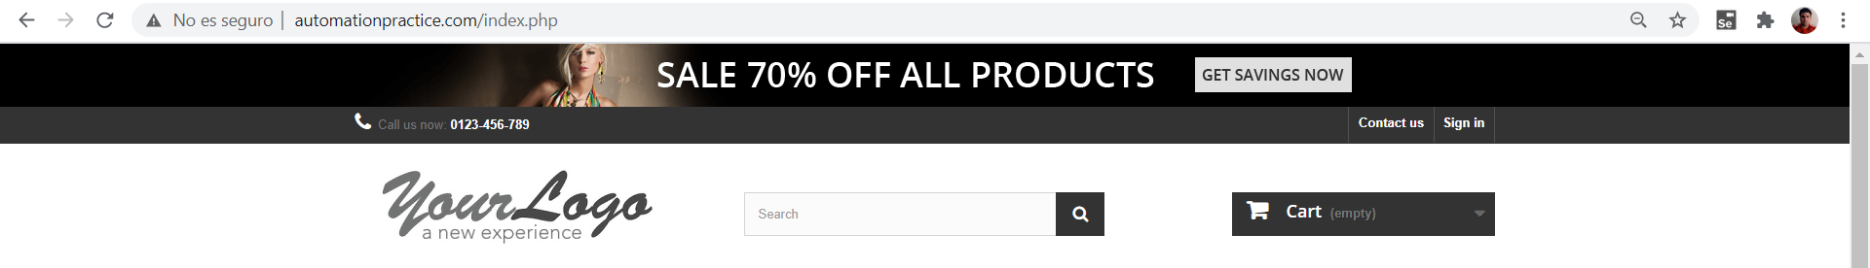

|  |  |
| --- | --- |
| **Defect 02** | Textbox is not available to introduce your mail. |
| **Expected result** | User must be able to introduce his/her mail to follow this page in social media. |
| **Actual result** | Textbox is not available to introduce text. |

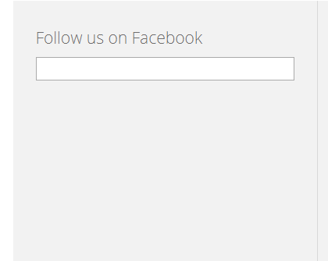

|  |  |
| --- | --- |
| **Defect 03** | Text has “pracitce” instead of “practice”. |
| **Expected result** | Text should not have grammar mistakes. |
| **Actual result** | There is a mistake in the word: “pracitce” |

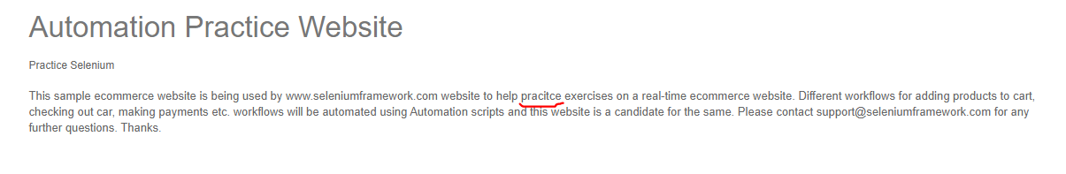

|  |  |
| --- | --- |
| **Defect 04** | Application freeze when user selects sort. |
| **Expected result** | When user selects a type of sorting, products must be sorted the way user selects. |
| **Actual result** | Loading icon is displayed and products are not sorted. |

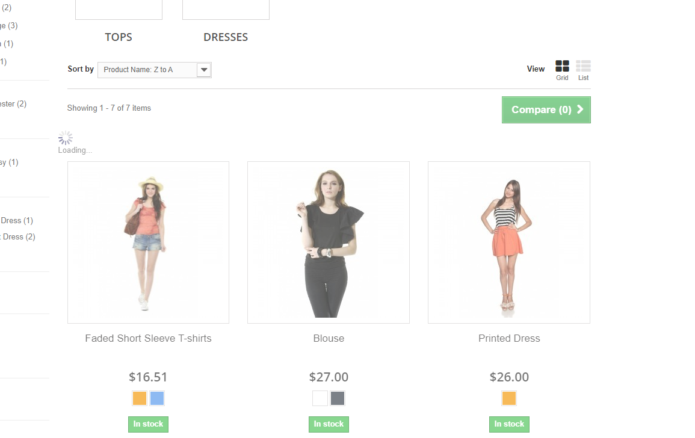

|  |  |
| --- | --- |
| **Defect 05** | Application freeze when user clicks on any checkbox. |
| **Expected result** | When user selects any checkbox, products according to the selected checkbox should be displayed. |
| **Actual result** | Loading icon is displayed and products does not change. |

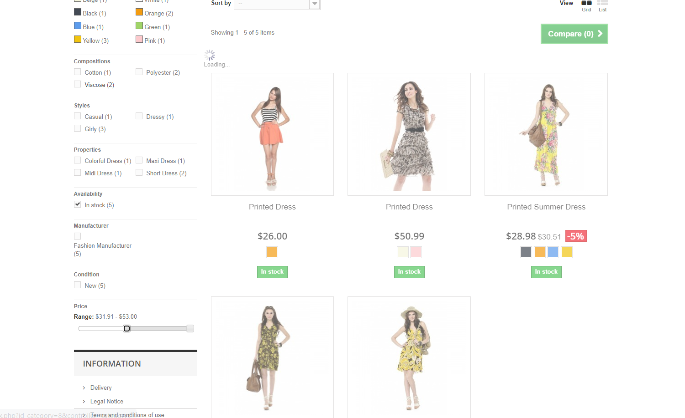

|  |  |
| --- | --- |
| **Defect 06** | Application freeze when user moves the slider. |
| **Expected result** | When user moves the slider, products must be sorted according to the price range. |
| **Actual result** | Loading icon is displayed and products are not sorted by price range. |

